Homepage for user to login.

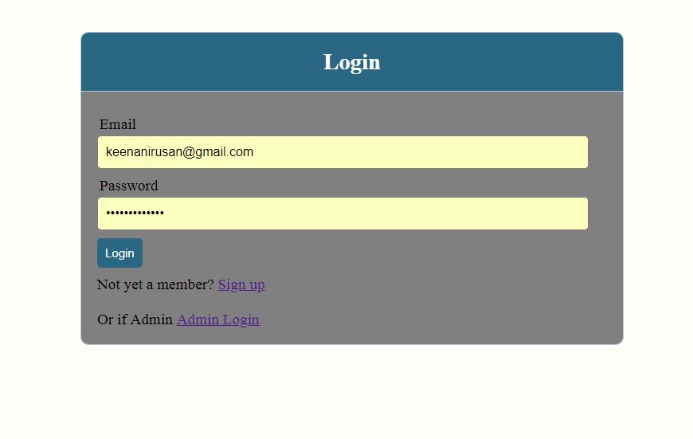

Register form to register new user into the database.

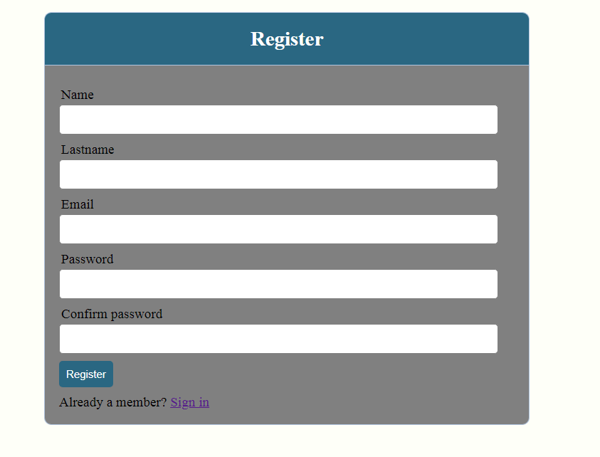

Products page where users select which products to buy by adding to cart.

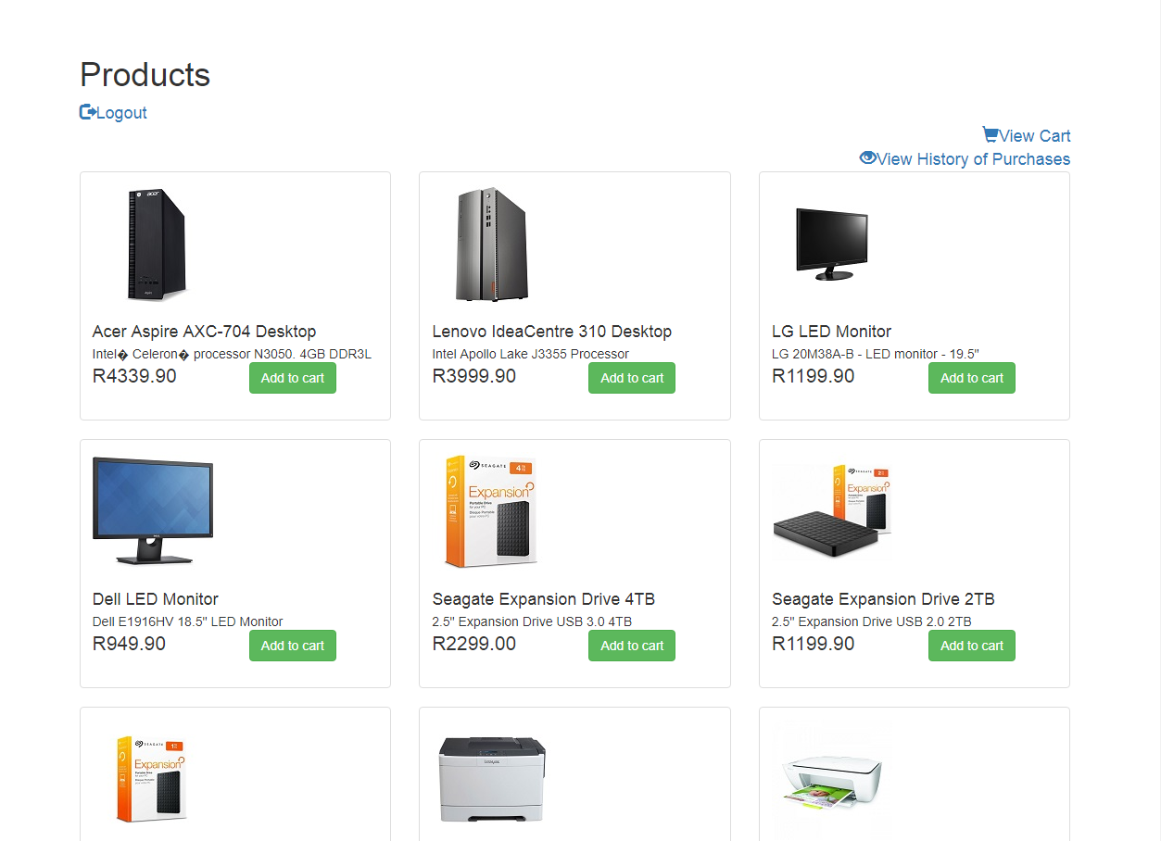

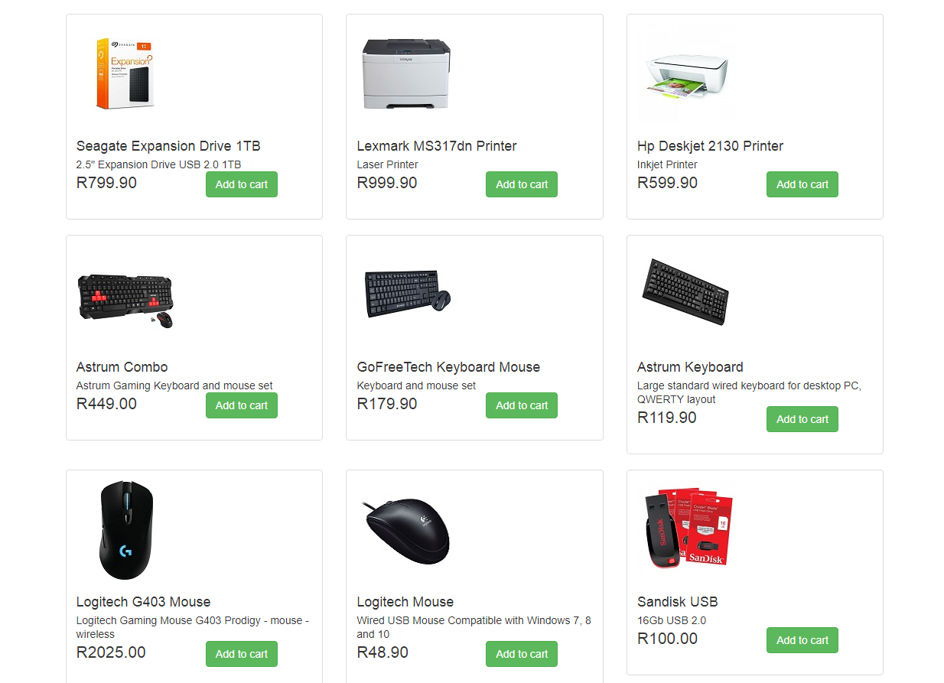

Shopping cart page.

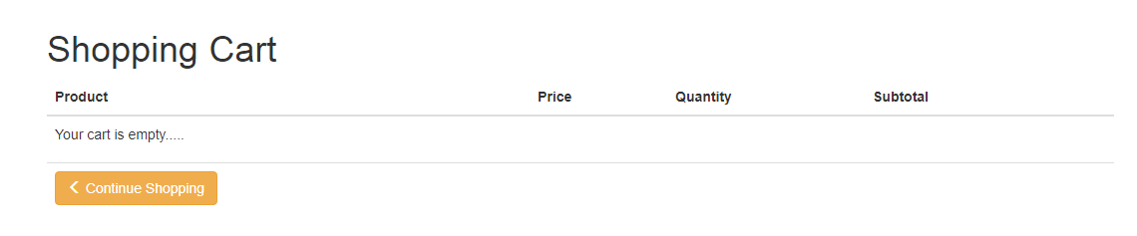

After user selects products, he/she can select the quantity of each or delete unwanted items. Then proceed to checkout.

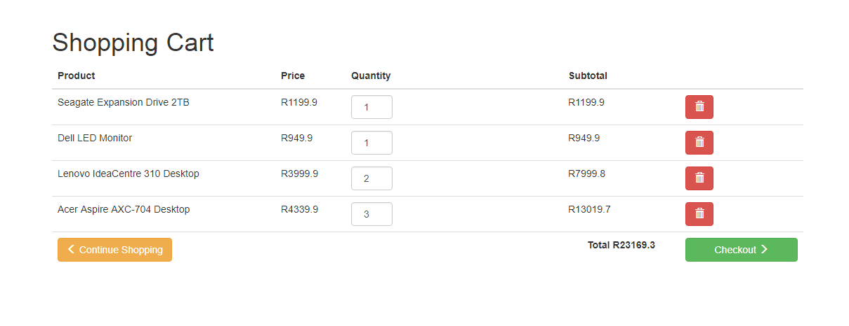

The order preview of the user with the products they have selected and the shipping details of the user. Then proceed to place order.

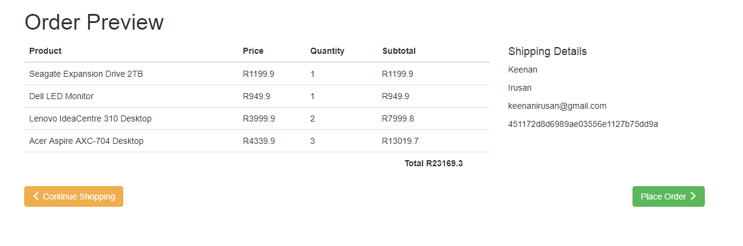

Order is submitted and user gets an Order ID.

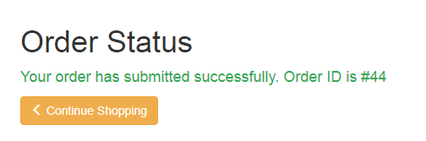

The user can select to logout, view cart again or view history of their purchases.



The history of the user, each order they made containing order ID and product ID of each.

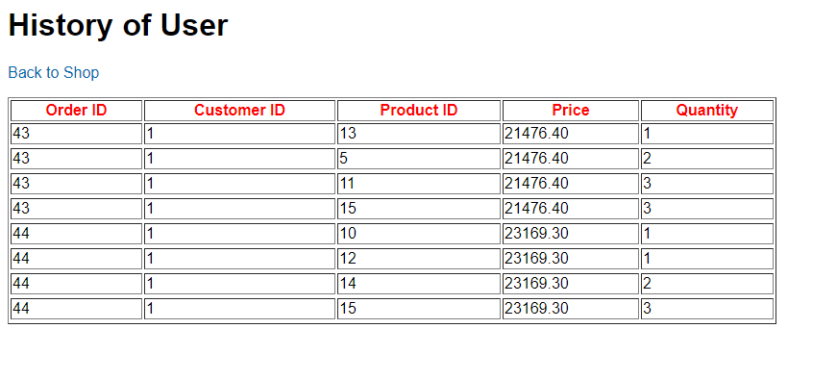

If admin, then select the admin link to login and view products table records.

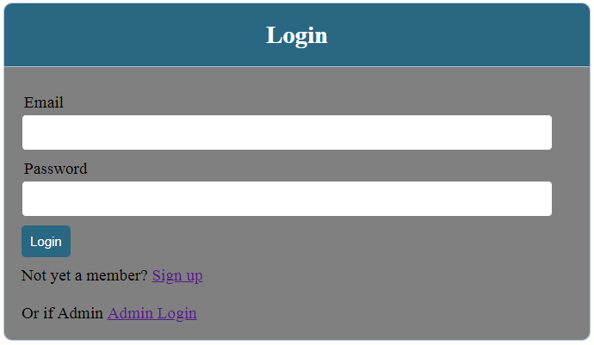

Admin enters their username and password and logs into system.

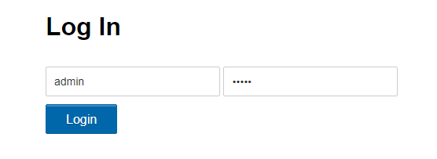

Products table. Admin can insert new records, edit and delete existing records.

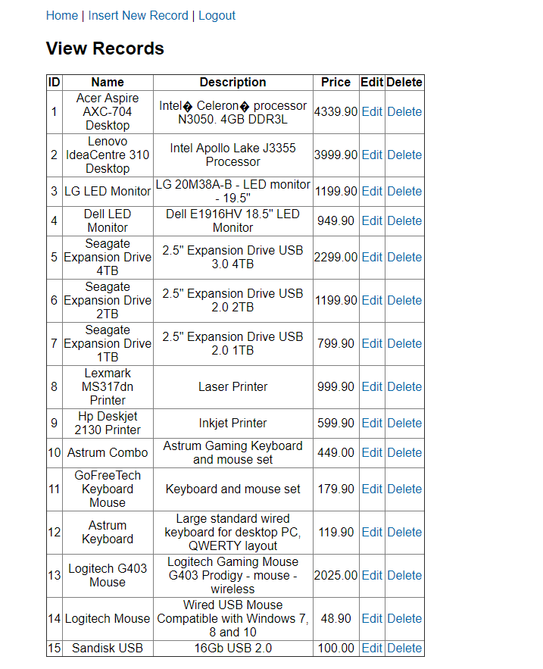

Admin inserting a new record

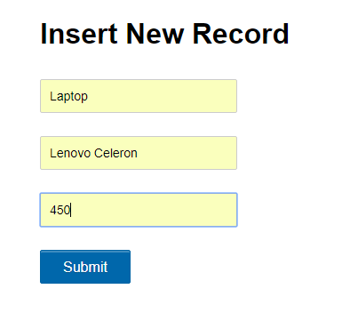

New record saved into the products table.

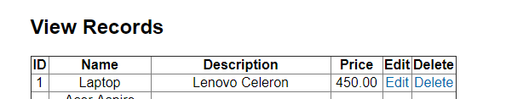

Admin can choose to update the record

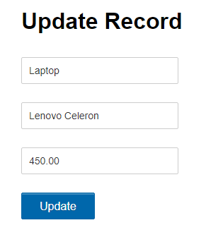

After record is updated successfully.



**/* Shopping Cart and Admin video within the task 3 folder will show how the website works. */**

All tables created within database.

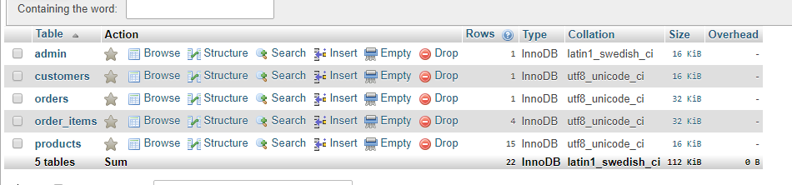

Products table

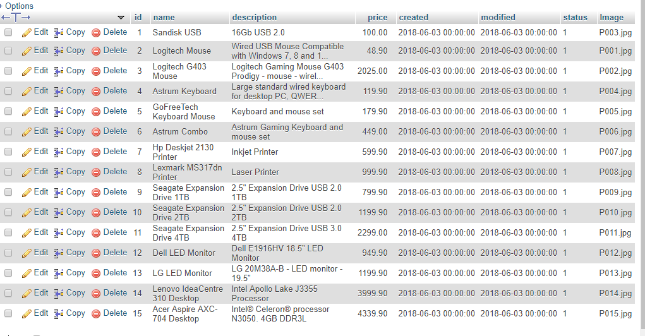

Customers table

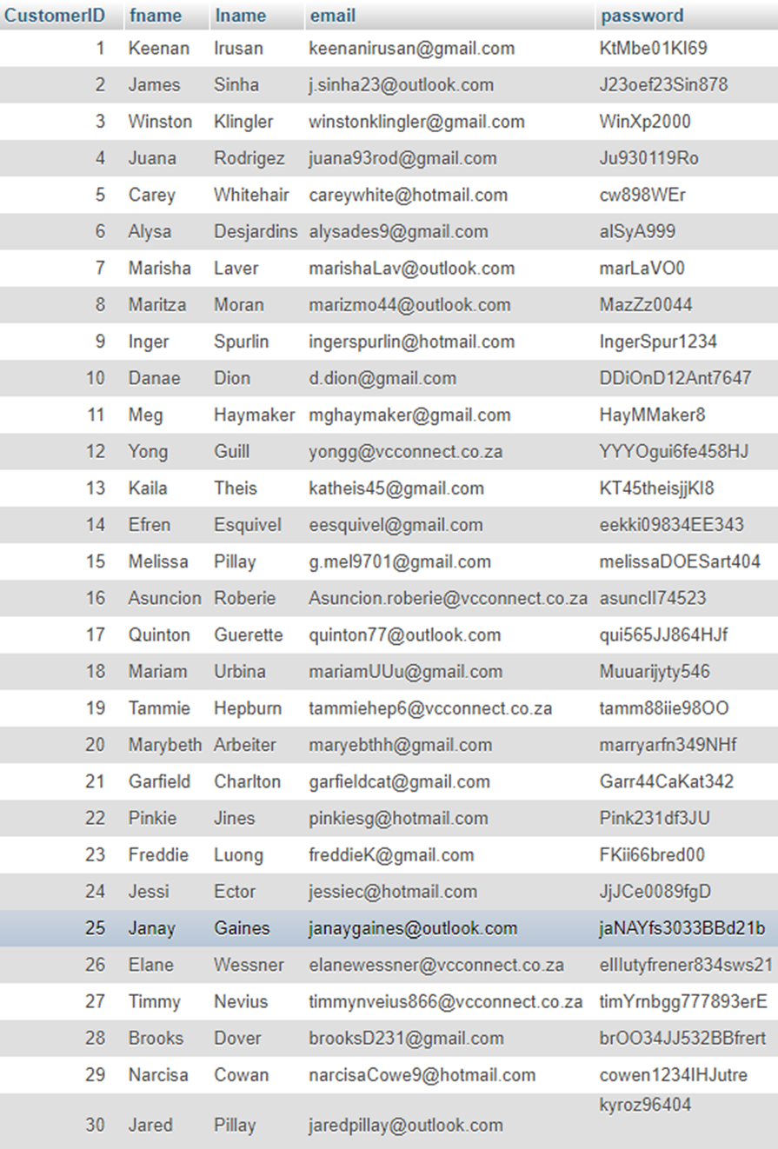

Orders table that contains customer_id and links it to the order_id

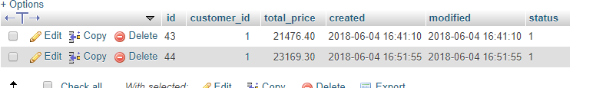

Orders Items table which links each order_id to the product_id

